Operational Concept Description (OCD)

CRCD Management System

Team 11

Muzzammil Imam – Project Manager
Jason Loewy – Developer, Tester
Fan Xu – Developer, Tester
Adarsh Khare- Developer, Tester
Kathleen Barrera - Tester

3/25/12

Version History
Date | Author | Version | Changes made | Rationale
09/22/11 | Yazeed, Erik | 1.0 | - Filled sections 1,2,3 | - Initial draft for FCP
10/12/11 | Yazeed |  | - Updates sections 1,2,3 | - Fix defects, response to client feedback
10/19/11 | Yazeed |  | - Updated sections 1.1,2.1,2.3,2.4,2.5, 3.1,3.2.1,3.3 | - Response to TA feedback
10/24/11 | Yazeed |  | - Updated sections 1.1,2.1,2.3,2.4,2.5, 3.1,3.2.1,3.3 | - Response to ARB feedback
11/07/11 | Yazeed | 4.1 | - Updated sections 2.4,3.3.1,3.3.2 | - Response to defects and TA feedback
11/17/11 | Erik | 4.2 | - Changed filename from “FCP” to “DCP” | - Perfectionist
12/01/11 | Yazeed | 4.3 | - Changed the ERD and the system boundary diagram | - ARB feedback
02/02/2012 | Jason | 5.0 | - Updated team roster  - Update RSM models in section 3.3.2  - Removed elements revolving around the handpunch scanner in various diagrams  - Made RSM models in section 3.3.2 more precise | - Removal of the handpunch system from the system  - Feedback from the DCP
03/25/2012 | Jason | 5.1 | - Updated footers  - Went into more detail on business workflow “Figure 7” and “Figure 9” | - Resolved BugZilla bugs  - Responses to RDCP feedback

Table of Contents
Operational Concept Description (OCD) i
Version History ii
Table of Contents ii
Table of Tables iv
Table of Figures v
1. Introduction 1
1.1 Purpose of the OCD 1
1.2 Status of the OCD 1
2. Shared Vision 2
2.1 Success-Critical Stakeholders 2
2.2 System Capability Description 2
2.3 Expected Benefits 3
2.4 Benefits Chain 4
2.5 System Boundary and Environment 5
3. System Transformation 6
3.1 Information on Current System 6
3.2 System Objectives, Constraints and Priorities 8
3.3 Proposed New Operational Concept 11
3.4 Organizational and Operational Implications 14

Table of Tables
Table 1: Success-Critical Stakeholders 2
Table 2: Capability Goals 8
Table 3: Level of Service Goals 8
Table 4: Relation to Current System 9

Table of Figures
Figure 1: Benefits Chain Diagram of CRCD Management System 4
Figure 2: System Boundary and Environment Diagram of CRCD Management System 5
Figure 3: Time Card Clocking in/out Business Workflow 7
Figure 4: Pick-up inventory items Business Workflow 7
Figure 5: Return inventory items Business Workflow 7
Figure 6: Element Relationship Diagram of CRCD Management System 11
Figure 7: Business Workflow Diagram of Time Cards System 12
Figure 8: Business Workflow Diagram of Checking-in Items in Inventory System 13
Figure 9: Business Workflow Diagram of Checking-out Items in Inventory System 13

Introduction

Purpose of the OCD

This document describes the shared vision, goals and benefits of the success-critical stakeholders of the CRCD Management System for the Coalition for Responsible Community Development (CRCD).

The success-critical stakeholders of the project include:

- Client: Brandy Chappel (Director of Operations.) and Shannon Ellis (Director of Social Ventures.)
- Managers, Payroll administrator and Employees of CRCD
- Development team: Team 11 in CSCI 577 course from USC

Status of the OCD
This is the version number 5.1 of OCD which will be part of the Initial Operational Capability Package. All sections have been filled in the prior semester. The document will be periodically updated to correct defects and reflect the latest state of the system in relation to OCD.

Shared Vision

Success-Critical Stakeholders
Table 1: Success-Critical Stakeholders
Stakeholder | Authorized Representatives | Organization | Relation to Benefits Chain
Client | Brandy Chappe l (Director of Operations)  Shannon Ellis (Director of Social Ventures) | Coalition for Responsible Community Development, (CRCD) | - Provide information and feedback to the development team.  - Looking up reports to show them to CRCD’s clients.
Managers | Shannon Ellis (Director of Social Ventures),  Jerry Walker(Career Placement Coordinator) | Coalition for Responsible Community Development, (CRCD) | - Provide information and feedback to the development team.  - Looking up reports to track inventory items and employees’ working hours.  - Approve time cards to make them available for payroll submission.  - Check in/out items from the inventory to keep track of them.  - Manage Employees data.
Employees | Shannon Ellis (Director of Social Ventures) | Coalition for Responsible Community Development, (CRCD) | - Wont directly be interacting with the system
Payroll Administrator | Erika Andrade | Coalition for Responsible Community Development, (CRCD) | - Approving time cards and submitting them to ADP.
Development Team | Fan Xu  Jason Loewy  Muzzammil Imam  Adarsh Khare  Kathleen Barrera | University of Southern California | - Responsible for implementing the whole system.  - Provide documentation and training for the system.

System Capability Description
A web-based system to electronically input time cards for employees that allows managers to approve them before they are sent to the payroll administrator. Additionally, there will be a web-based Inventory System, so managers can check in/out inventory items and track them. This will replace the necessity of physically transporting the paper time card sheets to the payroll administrator. By converting this process to an electronic one, there will be fewer errors. And by capturing this data, mangers will be able to reduce waste and manage resources more efficiently. Also, managers will be able to track their employee’s data.

Expected Benefits
- Better data organization and more data capturing.
- An easy to use system which can reduce errors and save time.
- Make important information easily accessible
- Increase CRCD’s clients’ satisfaction.
- Get more donations to change lives for the better.
- Show donors how their money is being spent.
- Decrease operational costs.
- Increase productivity for both employees and managers.

Benefits Chain
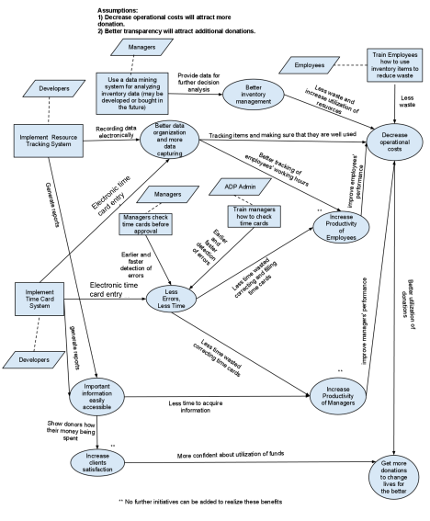
Figure 1: Benefits Chain Diagram of CRCD Management System

System Boundary and Environment

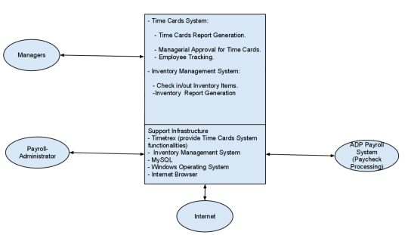
Figure 2: System Boundary and Environment Diagram of CRCD Management System

System Transformation

Information on Current System

Infrastructure
- Seven Personal Computers.
- One remote server hosted by GoDaddy.
- One local server.
- LE Hand Punch Devices.

Artifacts
- Time Cards: Record the date, time in/out, meal period start, meal period end, time out, regular hour, vacation hours and sick hours in a tabular format
- Inventory item check-in/out forms.
- Employee evaluation reports.

Current Business Workflow
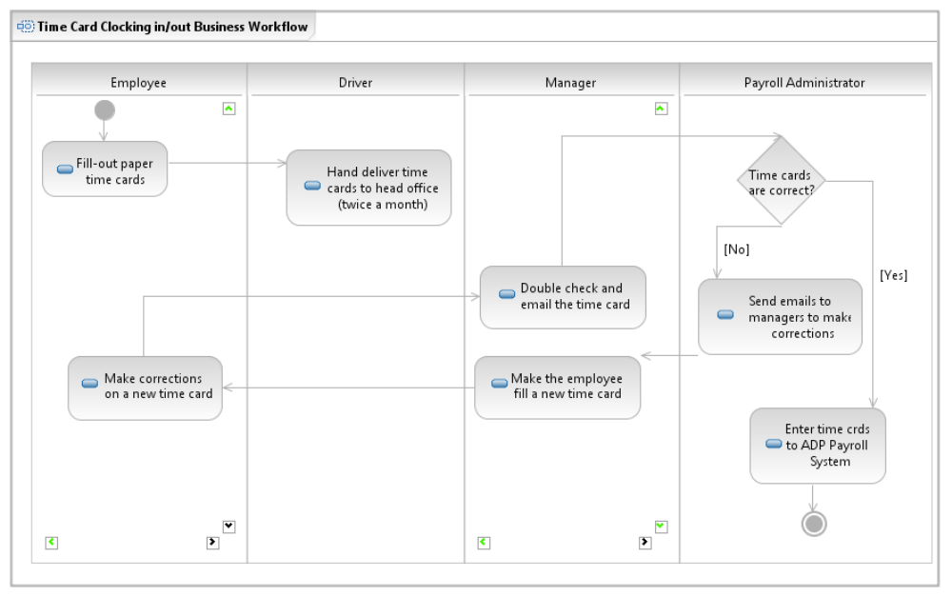
Figure 3: Time Card Clocking in/out Business Workflow

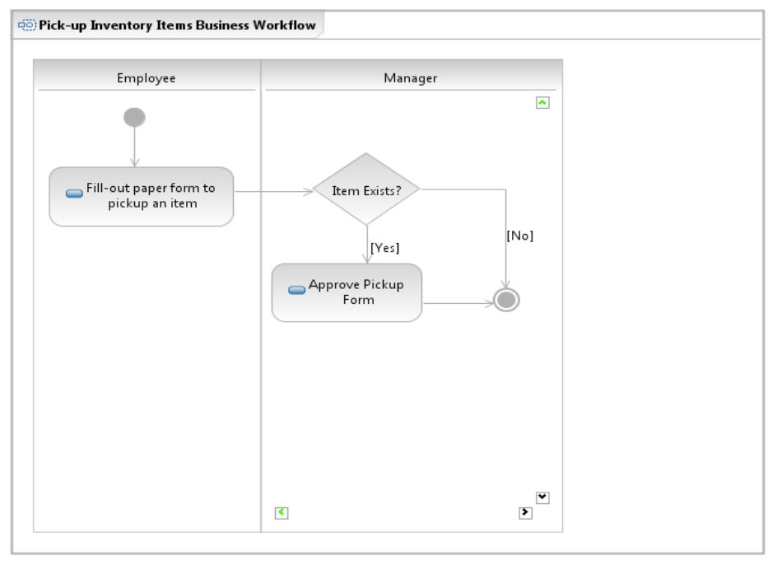
Figure 4: Pick-up inventory items Business Workflow

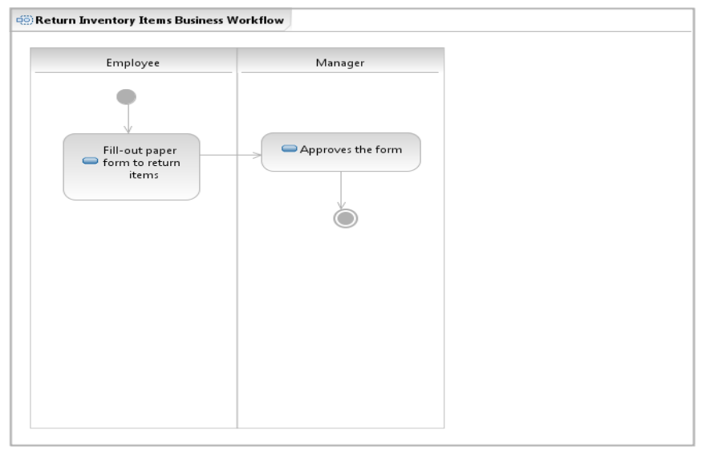
Figure 5: Return inventory items Business Workflow

System Objectives, Constraints and Priorities

Capability Goals
Table 2: Capability Goals
Capability Goals | Priority Level
OC-1 Report Generation: Managers must be able to print reports. | Must have
OC-3 Check in/out Inventory Items: Managers will use online forms to check in/out paint, tools and trucks | Must have
OC-4 Managerial approval for time cards: Managers will approve time cards before they are sent to the administrator | Must have
OC-5 Employee tracking: Managers can keep track of employees’ job history, reviews and pay raises | Could have
OC-6: Role based authentication: Mangers only should access the system by login using username and password. Employees will only punch in/out using the Hand Punch LE device. | Must have

Level of Service Goals
Table 3: Level of Service Goals
Level of Service Goals | Priority Level
LOS-1 Response time preferably within 10 seconds, but not more than one minute. | Must have
LOS-2 Scalability: The system should be able to handle 100 employees. | Must have
LOS-3 The system should be available during working hours from 8am to 6pm (PST) under normal conditions of operation (no power failure, no server crashes, etc.) | Must have

Organizational Goals

OG-: More accurate time cards using automated system.
OG-2 Reduce waste by tracking inventory usage by employees.
OG-3: Decrease operational costs and increase productivity by having Time Cards System and Inventory System.
OG-4: Attract more donations by providing accurate reports.
OG-5: Improve hiring and employee development by capturing and tracking employee information.

Constraints

CO-1: Windows as an Operating System: The new system must be able to run on Windows platform.
CO-2: Limited Budget: The selected NDI/NCS should be adhering to the limited budget.
CO-3: Limited Development Time: Everything must be finished within two semesters.
CO-4: Must Interface with Existing ADP Payroll System: ADP handles CRCD payroll processing.

Relation to Current System
Table 4: Relation to Current System
Capabilities | Current System | New System
Roles and Responsibilities | - A driver Manually delivers time cards to head office.  - Payroll administrator enters and approves time cards to ADP payroll system.  - Managers check in/out inventory items.  - Employees punch in/out  - Managers generate reports. | - Managers view and approve time cards.  - Payroll administrator approves and views time cards after managerial approval to submit them to ADP.  - Managers check in/out inventory items.  - An administrator grants managerial level access.  - Employees punch in/out.  - Managers generate reports.
User Interactions | Everything is paper-based:  - Employees fill-out paper time cards.  - Managers use paper forms to check in/out inventory items.  - Payroll administrator manually enters time cards into ADP.  -Manually generates reports. | Everything is done electronically:  - Employees punch in/out by hand punch device.  - Managers check in/out inventory items.  - Mangers approve time cards electronically.  - Payroll administrator approves and views time cards electronically.  - Much easier to generate reports than the old system.
Infrastructure | Everything is captured by paper. | Everything is captured in databases. Employees will use the Hand Punch LE connected to a workstation.
Stakeholder Essentials and Amenities | Lack of electronically monitoring when employees clock in/out. Failing to capture information about inventory and employees. | - Electronic system to clock in/out.  - Capture information about inventory and employees.
Future Capabilities | Doesn’t offer integrated or automated project management tracking. | The Inventory System can be upgraded in the future to capture additional data and additional resources.

Proposed New Operational Concept

Element Relationship Diagram
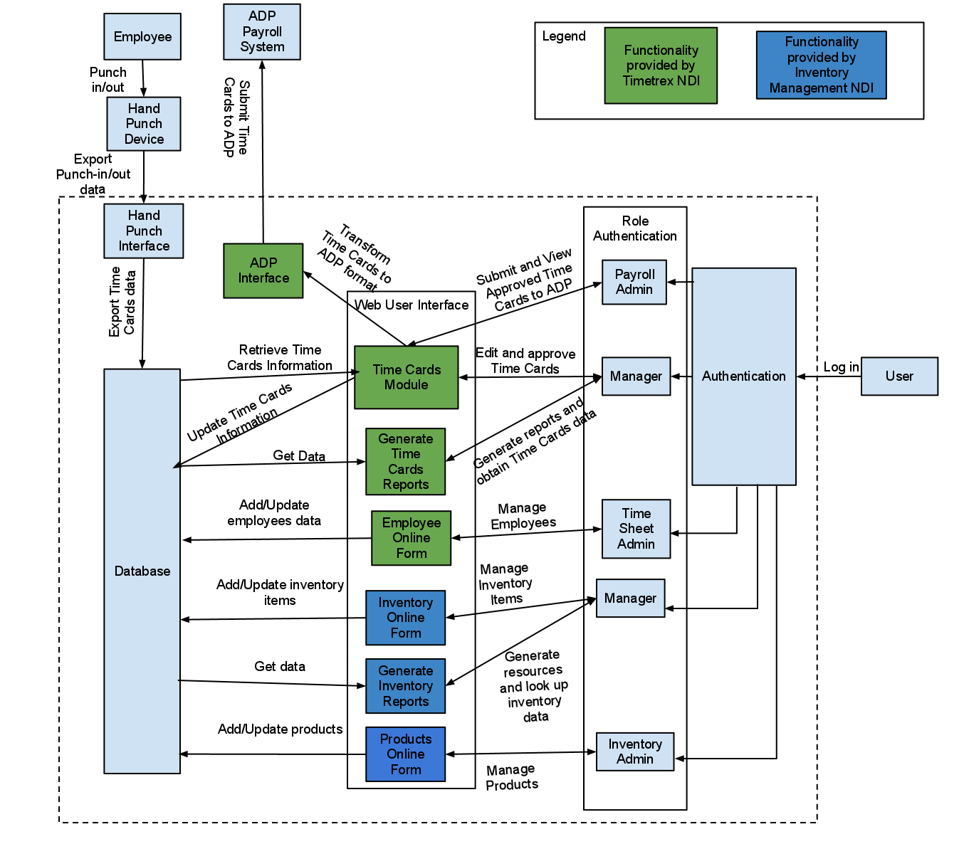

Figure 6: Element Relationship Diagram of CRCD Management System

Business Workflows
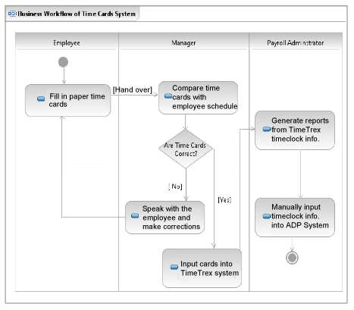
Figure 7: Business Workflow Diagram of Time Cards System

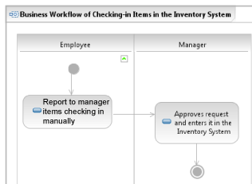
Figure 8: Business Workflow Diagram of Checking-in Items in Inventory System

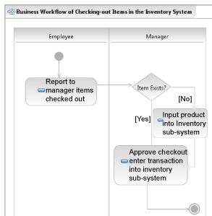
Figure 9: Business Workflow Diagram of Checking-out Items in Inventory System

Organizational and Operational Implications

Organizational Transformations

Managers will be required to approve employee time cards before they are sent to payroll administrators by reviewing them into the TimeTrex system once they have input them. Employees will be more responsible for the resources they use since these resources are tracked effectively. Periodically a Maintainer will have to backup the system databases. An administrator will be responsible for granting managerial access.

Operational Transformations
Employees will continue to fill out paper time cards and hand them over to their managers. The managers will then input those timecards data into the TimeTrex system. A driver will no longer be required to carry time cards to Payroll administrators. Managers will now approve time cards. This will help to catch errors early and save time overall. Manager will check in/out inventory items using the Inventory System and finally have inventory information easily available. Payroll-administrators will no longer have to enter time cards into ADP manually; instead they will pull that data from the Time Cards System and submit time cards to the payroll system (ADP) after managerial approval to these cards.

